5.4.3 Conic Sections (Hyperbolas)

If a plane passes through a double right circular cone there are four possible resulting curves. These curves are the parabola, circle, ellipse, and hyperbola. These curves are called conic sections and are shown below.
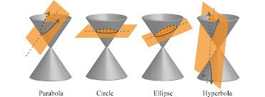

Definition: A hyperbola is the set of all points in a plane such that the difference between the distances from two fixed points (foci) is constant.
*Note the subtle difference between this definition and the definition for an ellipse which has the sums of differences from two fixed points as constant.*

The Equation of a Hyperbola: (opening left or right)
The equation of a hyperbola with center at the origin with foci and
x-intercepts is
where

The differences of the distances from any point of the hyperbola to the two foci is 2a.

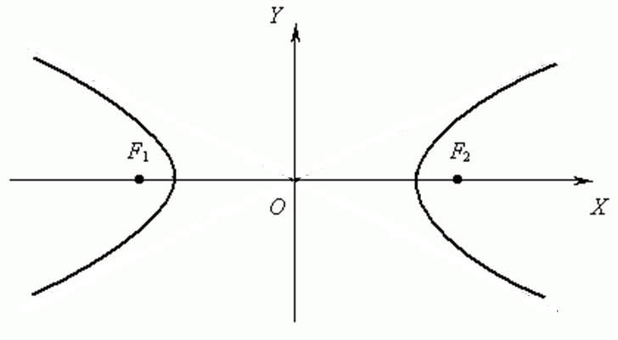
$$(-c,0)$$
$$(c,0)$$
$$(a,0)$$
$$(-a,0)$$

Developing the Equation of a Hyperbola (Not covered in class)

$$(-c,0)$$
$$(c,0)$$
$$(a,0)$$
$$(-a,0)$$
$$(x,y)$$
$$a$$
$$a$$
$$c-a$$
$$c-a$$

Note that the distance between is .
Note that the distance between is .
Therefore the constant difference is .
So for an arbitrary point we want to still have the constant difference 2a.
Note that since then , so . So let .

The Equation of a Hyperbola: (opening up or down)
The equation of a hyperbola with center at the origin with foci and
x-intercepts is
where

The differences of the distances from any point of the hyperbola to the two foci is 2a.

Note: With hyperbolas it is not important whether a or b is the larger value. We always think of a as the value beneath y and b as the value beneath x.

Graphing a Hyperbola
If we solve the equation for y we obtain
Notice that as , we see that
Therefore, we have oblique (slant) asymptotes with the equation:
If we have a hyperbola that opens up or down the equation of the asymptotes is given by:

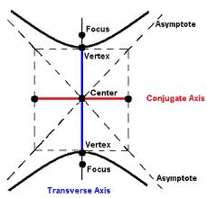
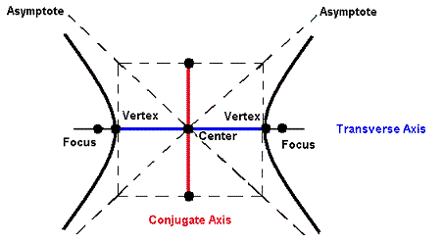
Example 1: Determine the foci, equations of the asymptotes, and sketch the graph of

We have ,
So the foci of the hyperbola are
We know that the asymptotes are given by the equation
So our asymptotes are:
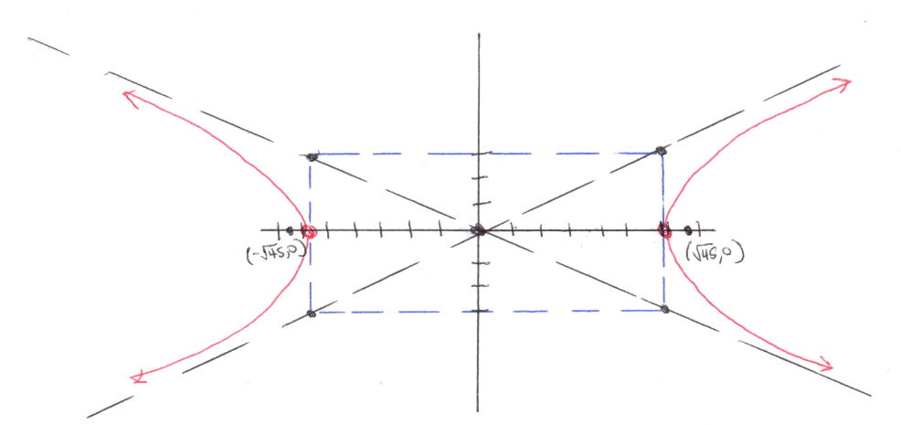

Example 2: Determine the foci, equations of the asymptotes, and sketch the graph of
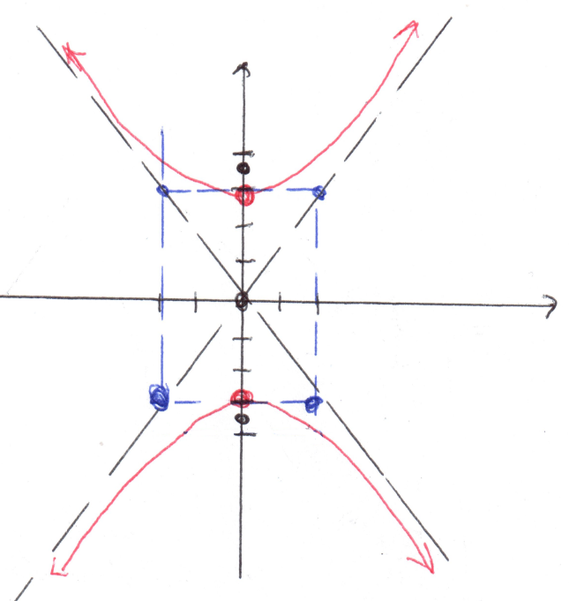
First we divide each side by 36 to get the equation in standard form.
We have
So the foci of the hyperbola are
We know that the asymptotes are given by the equation
So our asymptotes are:

Example 3: Determine the foci, equations of the asymptotes, and sketch the graph of

The center of our graph has been shifted from the origin to the point:.
We have
So the foci of the hyperbola would have been the points had we still been centered at the origin. Since we are centered at the point we must add 2 to the x-coordinate and add -1 to the y-coordinate. So now the foci are
Similarly we can see that the asymptotes of the graph would have been had the graph been centered at the origin. Since we are centered at the point we must add 2 to the x-coordinate and add -1 to the y-coordinate. So now the asymptotes are
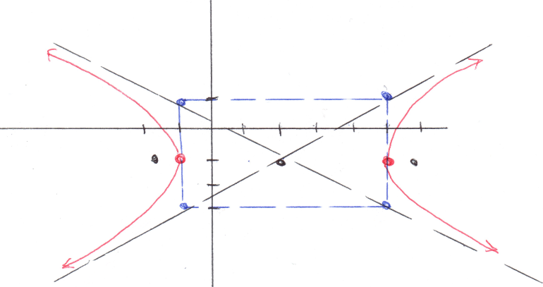

Example 4: Find the equation of a hyperbola whose transverse axis had endpoints and whose conjugate axis has endpoints .

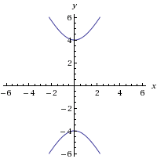
The transverse axis is the distance between the vertices so we see that our hyperbola opens up and down and that which implies that .

So our equation is:

Example 5: Find the equation of the hyperbola with asymptotes and vertices .

Since the vertices are we know the hyperbola is centered at the origin and .
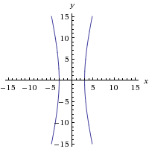
Since the asymptotes go through the vertices of the fundamental rectangle, we know they pass through the point . So we have that .

Therefore, the equation is:

Recapping Section 5.4

Example 6:
- Find an equation for the parabola with vertex , axis of symmetry , and which contains the point .
- Find the vertex/vertices of the conic determined by the equation .
- Find an equation of the ellipse with foci , and vertices , .

Solutions:

Based upon the given we know that this parabola opens upward. Since its vertex is at we know that the desired equation is of the form . We also know that must satisfy this equation. Thus, we have .
Thus, the desired equation is

We must complete the square in order to get the equation in a form that we can recognize.
From this we recognize that the equation determines a hyperbola with vertical transverse axis and center . Since , we conclude that the vertices are and .

We know that the center of the ellipse has to be at the midpoint of the major axis. Thus, the center is . Also we see that and . Since , we know that . Thus, the desired equation is .

